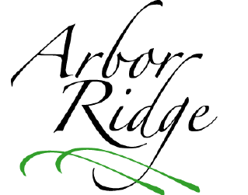Arbor Ridge Homeowners’ Association

Fall Newsletter

November 22, 2016

**Save the date for annual HOA meeting**

The annual general membership meeting of the Arbor Ridge Homeowners’ Association will take place at 7 p.m. on Monday, December 12, at Gustavo’s Mexican Grill. Heavy appetizers and non-alcoholic beverages will be provided by ARHOA. Additional details will be sent to homeowners soon. Watch for a flyer!

C:\Users\Owner\AppData\Local\Microsoft\Windows\Temporary Internet Files\Content.IE5\YVZ2BBGC\MC900151699[1].wmf

**Consider joining the ARHOA Board**

During the annual HOA meeting, we will elect the 2017 Board of Directors. Please consider serving next year, as several current Board members will be resigning at the end of the year. Nominations for the Board can be made verbally at the meeting, and self-nomination is strongly encouraged!

**It’s tree-trimming time…and we don’t mean Christmas trees!**

Arbor Ridge homeowners are responsible for maintaining their property, including the ash trees along our roadways. Many of our ash trees have low-hanging branches that are making it difficult for people using our sidewalks and vehicles traveling in our neighborhood. Please make plans to remove all low-hanging branches from these trees as soon as possible. Otherwise, we will contact you about having your tree(s) professionally trimmed at your expense. (You can send an e-mail to [HOA@arborridge-crestwood.com](mailto:HOA@arborridge-crestwood.com) if you are would like more information about having this work completed by professionals at a reasonable rate.)

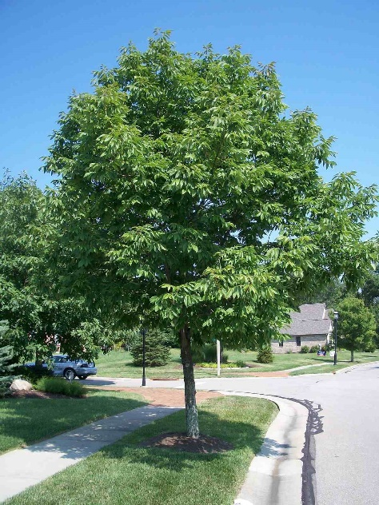

**Arbor Ridge management**

Arbor Ridge is professionally managed by Kentucky Realty Corporation. If you have any neighborhood questions or concerns, you should contact Deanna Dome at (502) 473-0003 or [dmyers@kyrealtyonline.net](mailto:dmyers@kyrealtyonline.net).

**2017 HOA dues notices have been sent**

Kentucky Realty Corporation sent a letter and invoice for 2017 HOA dues to all Arbor Ridge homeowners on Oct. 31. (If you do not have this invoice, you should contact Deanna Dome at your earliest convenience. Her contact information is listed above.)

Your HOA dues will increase by $25 in 2017 to $325. This modest increase will help offset the rising cost of landscaping, maintenance, electricity, and emerald ash borer treatments (for the ash trees along our roadways).

Please submit your dues for 2017 as soon as possible, and do not be alarmed by the Las Vegas mailing address. Kentucky Realty uses Alliance Association Financial Services (AAFS), which has an office in Las Vegas, NV.

C:\Users\Owner\AppData\Local\Microsoft\Windows\Temporary Internet Files\Content.IE5\YVZ2BBGC\MC900311034[2].wmf

**Please maintain your property!**

In addition to tree-trimming, several AR residents need to take some additional steps to maintain their property. In particular, there are a number of fences and mailboxes that need to be repaired and/or repainted.

**Exterior home improvement projects require Board approval**

Are you planning any home improvement projects in 2017, such as a new pool, deck, or fence? Just a reminder that outdoor projects require the approval of the ARHOA Board of Directors. You can download an Exterior Improvement Application form on our website: <http://arborridge-crestwood.com>. (It is listed under *Documents* > *Forms*.) Interior improvements projects and routine repairs **do not** require approval.

**Board to discontinue use of PO Box**

In an effort to reduce our costs, the Arbor Ridge Board has decided to discontinue the use of our PO Box in 2017. If you wish to send any documents/forms (such as Exterior Improvement Applications) through the mail, please send them to Deanna Dome at the following address:

Kentucky Realty Corporation

3944 Bardstown Road

Louisville, KY 40218