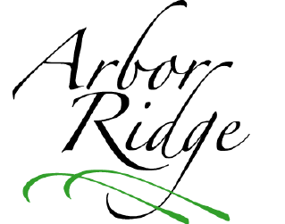Arbor Ridge Homeowners’ Association

Summer Newsletter

June 18, 2012

**Date set for neighborhood yard sale**

You are invited to participate in Arbor Ridge’s neighborhood yard sale on Saturday, July 14. ARHOA will place signs at both entrances on the day of the sale, and will also place an advertisement in the Oldham Era (and possibly, the Courier-Journal). So, start cleaning out your closets and basement today!

C:\Users\Owner\AppData\Local\Microsoft\Windows\Temporary Internet Files\Content.IE5\BH79STGL\MC900439885[1].wmf

**No neighborhood party this July**

Arbor Ridge will **not** host a neighborhood party this summer due to the lack of interest expressed by homeowners in the questionnaire distributed earlier this year. Only 13 of the 89 homeowners in the subdivision indicated that they would attend a July 4th neighborhood party, and only a few additional residents would attend if the date were changed. Some neighbors also expressed concern with the use of dues for social events. The Board will revisit this issue in 2013.

**Checked your sidewalk & trees lately?**

Please note that all homeowners are responsible for maintaining the sidewalk on their property. Some sections of our neighborhood sidewalk pose severe tripping hazards. (A few of us know from experience!) Also, some residents need to trim trees that are blocking sidewalk access. If you cannot walk along your portion of the sidewalk without ducking, please trim your trees!

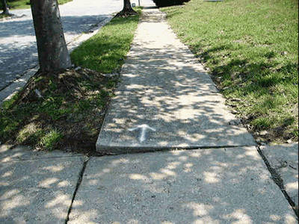

**Got a problem?**

ARHOA hired Bill Shannon of KMS Property Management to help us address the questions and concerns of our neighbors in a timely manner. If you have an issue, please contact Bill by phone at (502) 905-9150 or by e-mail at kmsproperty@insightbb.com.

(Newsletter continued on back page)

**Exterior home improvement projects, play sets, etc. require Board approval**

Are you planning any home improvement projects this summer? Do you want to add a play set or pool for the kids? Thinking about building a fence? Please keep in mind that these types of outdoor projects require the approval of the ARHOA Board of Directors. You can download an Exterior Improvement Application form on our website: http://arborridge-crestwood.com. (It is listed under the Forms section of the site.) Interior improvements projects and routine repairs **do not** require approval.

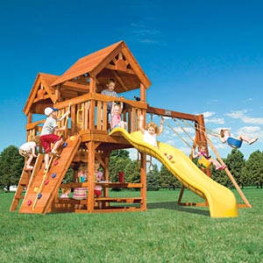

**‘Tis the season for yard work**

Please be considerate of your neighbors and take the necessary steps to treat your yard for weeds and maintain a well-kept lawn in 2012. This is not only a good idea, but also a requirement addressed in the AR Declaration of Restrictions:

(Continued in next column)

(Continued from previous column)

“All lots shall be properly cut, weeded, and maintained. ARHOA reserves the right to approve or disapprove the general appearance or condition of any lot. If an owner fails to maintain a lot, ARHOA reserves the right to mow or perform other necessary services on same and charge the owner a reasonable fee for the work, which charges shall constitute a lien upon the property” (p. 5).

C:\Users\Owner\AppData\Local\Microsoft\Windows\Temporary Internet Files\Content.IE5\IL35LCWB\MC900330854[1].wmf

**2012 ARHOA Board**

The members of the ARHOA Board of Directors for 2012 are as follows:

Jonathan Watkins, President

Sam Gardner, Secretary

Dorothy Kuyk, Treasurer

Mark Ochsner, VP of Maintenance

Stacy Bellis, VP of By-law Compliance

**Need to contact ARHOA?**

E-mail: HOA@arborridge-crestwood.com

Mail: P.O. Box 201, Crestwood, KY 40014