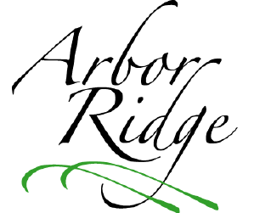
Arbor Ridge Homeowners
Activity Announcements and Requests

The Arbor Ridge Homeowner’s Association Board of Directors would like to support homeowners’ requests for neighborhood events and activities whenever possible, and would also like to offer assistance in advertising your events on the Arbor Ridge web site. Please complete the following request form so that we may be of assistance in the planning, implementation, or posting of neighborhood events. Please email your request to HOA@ArborRidge-Crestwood.com, within 6 weeks of the event to allow discussion, feasibility, planning, or posting to the web site to take place.

Title of Activity/Event: ____________________________________________

Date(s): _________________________ Time(s): ______________________

This request is for:
______ Request to advertise event on the Arbor Ridge web site.
**Please forward your flier or pertinent information by mail or email

______ Request for an event to be planned
*** Please complete the information below and send by mail or email

Is this activity/event geared to…

___ Families ___ Children ___ Adults only ___ All inclusive ___ Women ___ Men ___ Teens

Brief Summary: __________________________________________________

______________________________________________________________

Contact Person: _________________________ Phone #: _________________

Kind of Event/Activity:

_____ Fundraiser _____ Social Event _____ Other: ____________

_____ Neighborhood Improvement

Will you request funds from the Homeowner’s Association? ______
If so, how much money are you requesting? $____________

Will admission be charged? ________ If so, how much? $____________
Please add any additional comments, needs below. _________________________

______________________________________________________________

