e-mail form to :
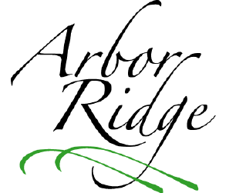
HOA@ArborRidge-Crestwood.com

Arbor Ridge Home Owners Association Complaint/Grievance Form

Name: _______________________________ Date: __________________

Grievance/Complaint based on: By-Laws Deed Restrictions Other
(Circle One)

Nature of Grievance/Complaint:

Actions Previously Taken by Submitter (if applicable):

Remedy Suggestions:

Signed: ______________________________ Page 1

Page 1 is to be completed by the Home Owner.
Page 2 is to be completed by a member of the Home Owners Assoc. Board or Directors.

Arbor Ridge Home Owners Association Complaint/Grievance Form

(To be completed by a Board Member)

Facts and Information Considered by the Board:

Actions Considered by the Board (if applicable):

Board Suggestion/Recommendation/Final Decision (circle one):

Response Date (back to submitter): _______________________

Signed: ______________________________

Title: ________________________________

Page 2
Page 1: to be completed by the Home Owner.
Page 2: to be completed by a member of the Home Owners Association Board of Directors.

